Find the eno ename ,salary whose salary >4000 and job_status =professor

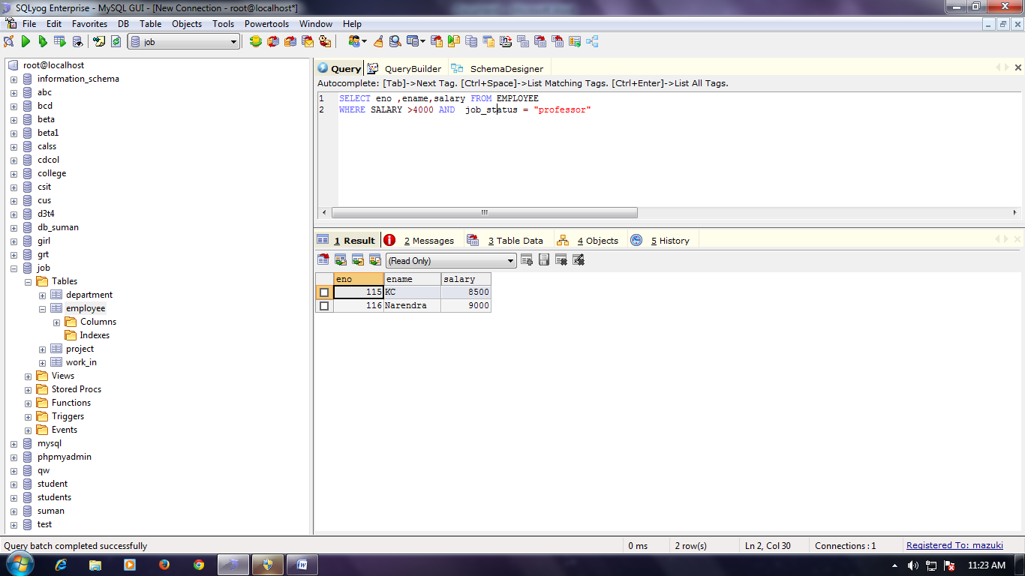

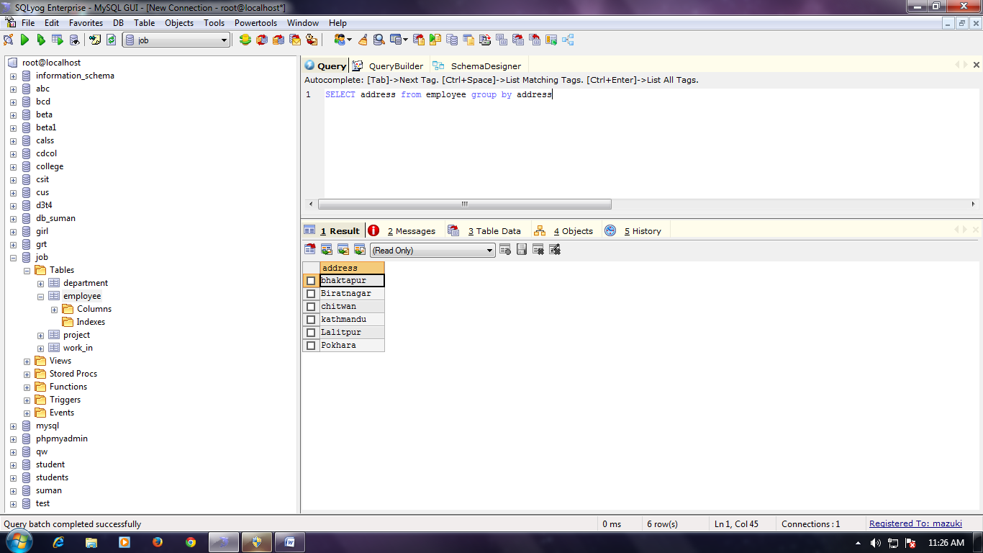

Find the eno ename ,salary whose salary >4000

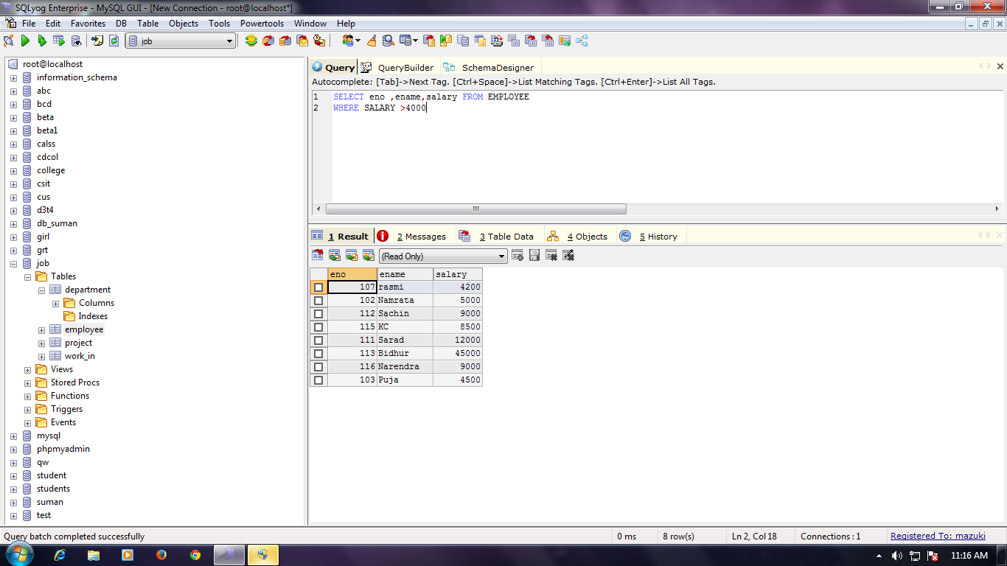

Find the eno ename ,age,salary whose age is between 20 and 28

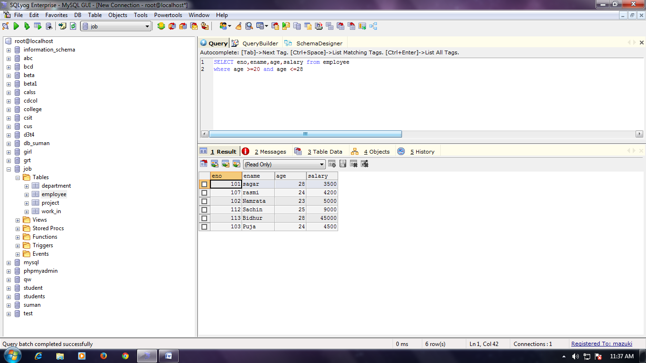

Find the eno, ename ,salary whose depno=20 and job status =research fellow

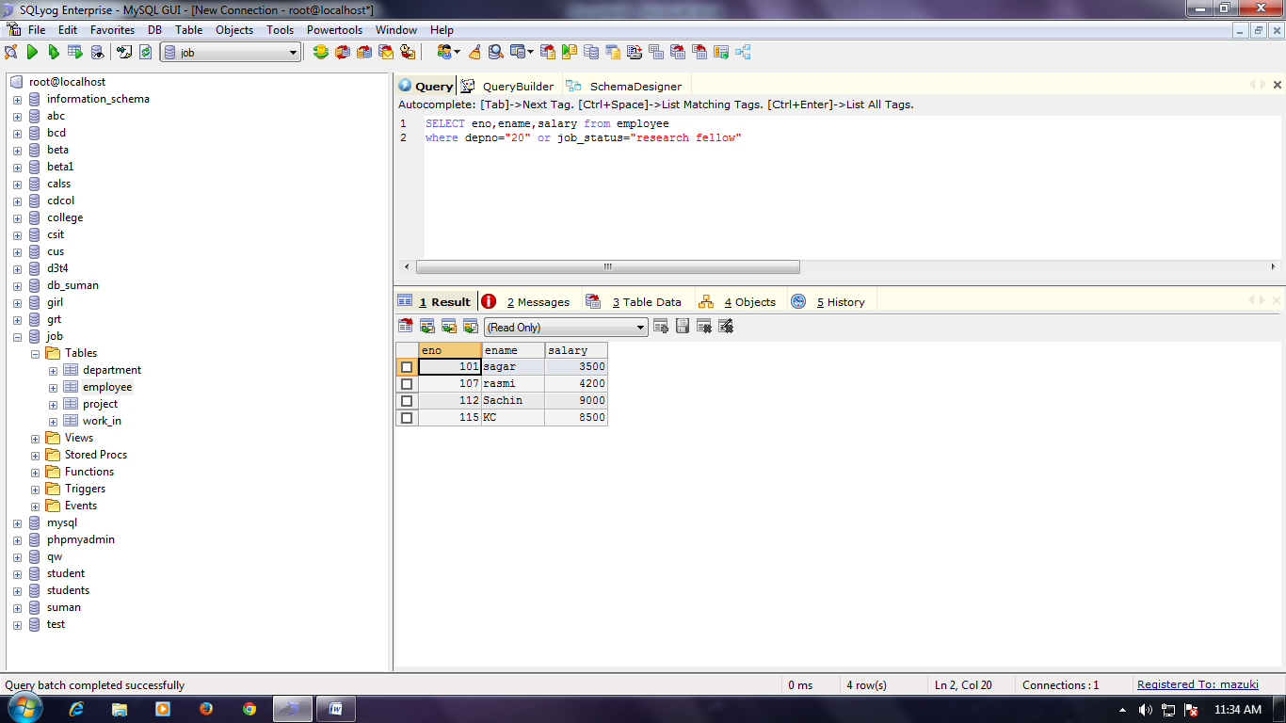

WHOSE STARTING NAME ‘SA’

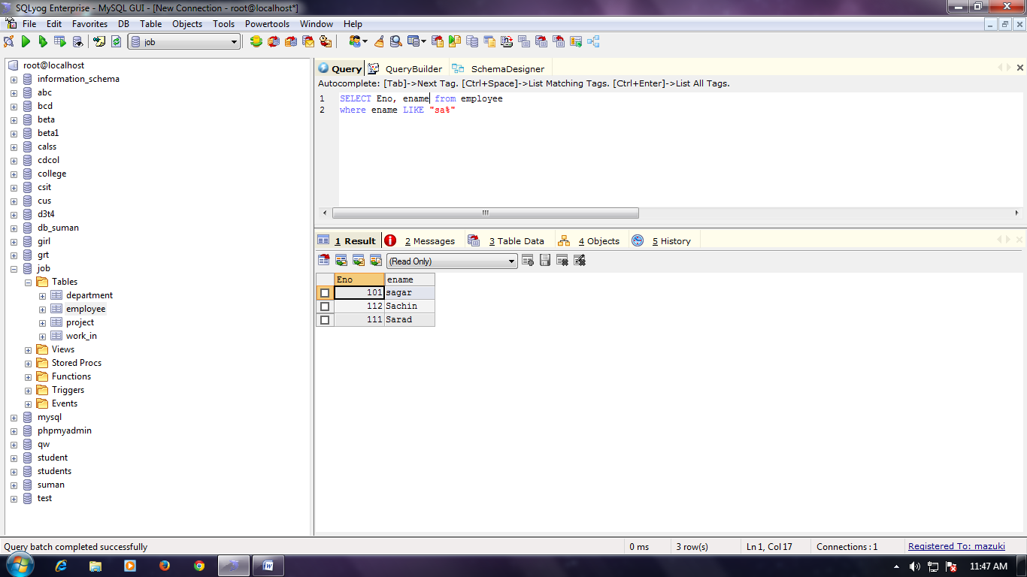

List All employee with their project name

List nam 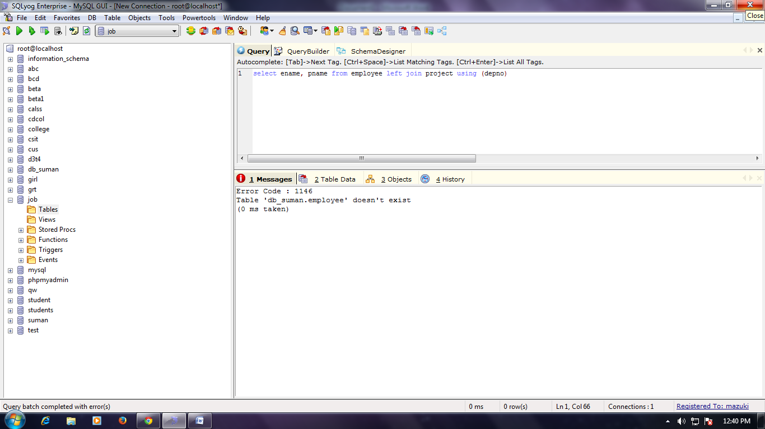e of all employee and their salary working in project mars and venus